create database insurances;

use insurances;

create table person(driver_id varchar(10),

name varchar(20),

address varchar(30),

primary key(driver_id));

desc person;



create table car(reg_num varchar(10),

model varchar(10),

year int,

primary key(reg_num));

desc car;

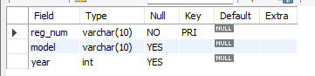

create table accident(report_num int,

accident_date date,

location varchar(20),

primary key(report_num));

desc accident;

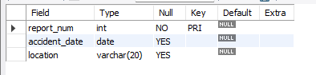

create table owns(driver_id varchar(10), reg_num varchar(10),

primary key(driver_id,reg_num),

foreign key(driver_id) references person(driver_id),

foreign key(reg_num) references car(reg_num));

desc owns;



create table participate(driver_id varchar(10), reg_num varchar(10),

report_num int, damage_amount int,

primary key(driver_id,reg_num,report_num),

foreign key(driver_id) references person(driver_id),

foreign key(reg_num) references car(reg_num),

foreign key(report_num) references accident(report_num));

desc participate;

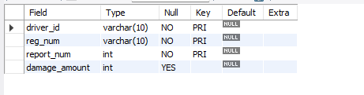

insert into person values(12345,"sai","basavangudi"),(13456,"charan","hanumantha nagar");

insert into car values("KA12AB1234","indica",1990),("KA13KK3142","toyota",1998);

insert into accident values(12,"2024-12-3","bangalore"),(13,"2024-12-5","chennai");

insert into participate values(12345,"KA12AB1234",12,678994),(13456,"KA13KK3142",12,1500);

insert into owns values(12345,"KA12AB1234"),(13456,"KA13KK3142");

select accident_date,location from accident;

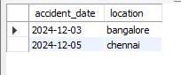

select p.name , pr.reg_num

from person p, participate pr

where (p.driver_id=pr.driver_id) and pr.damage_amount>=25000;



select p.name,c.model

from person p, car c, owns o

where (o.driver_id=p.driver_id) and (o.reg_num=c.reg_num);

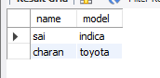

select a.location,p.name,pr.damage_amount

from accident a, person p, participate pr

where (pr.driver_id=p.driver_id) and (pr.report_num=a.report_num);



select driver_id,sum(damage_amount)

from participate pr

group by driver_id;

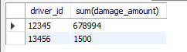

select driver_id, count(report_num) as accident_count

from participate

group by driver_id

having COUNT(report_num) > 1;



select *

from accident

where accident_date=(select max(accident_date) from accident);

select driver_id,avg(damage_amount)

from participate

group by driver_id;

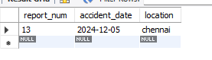

update participate set damage_amount=25000 where reg_num="KA12AB1234" and report_num=12;

select * from participate;

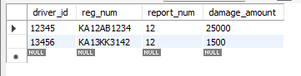

select driver_id

from participate

where damage_amount=(select max(damage_amount) from participate) ;

